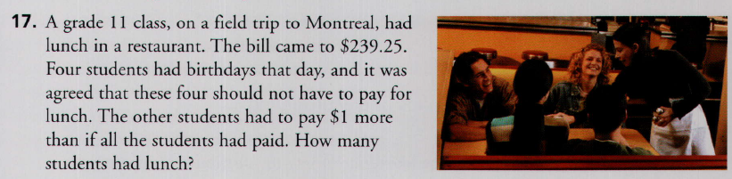
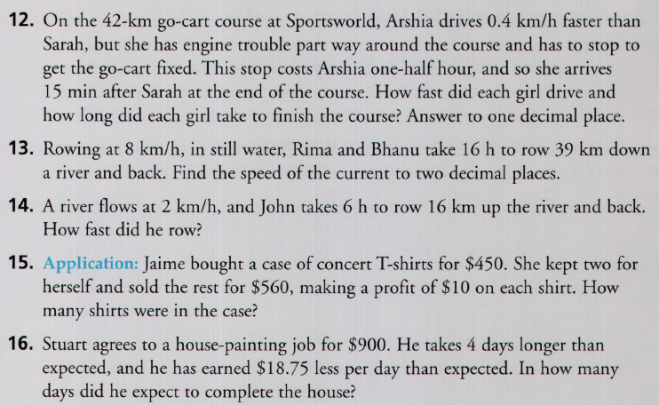
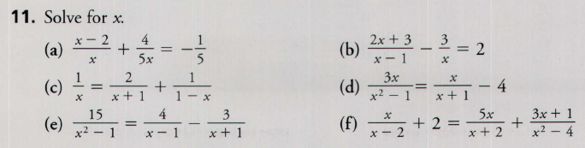
3.80 Solving Rational Equations Questions

